**Steganography Project Master Test Plan**

Linden Crandall, Jonathan Mainhart, Zhihua Zheng

University of Maryland Global Campus

CMIS 495: Current Trends and Projects in Computer Science

Prof. Majid Shaalan

April 29, 2022

# Introduction

This document contains test cases used to measure functionality of the application. The tests were run on four different systems listed in table 1. Automated unit test cases for the backend (application logic) and frontend (user interface) are contained in table 2 and table 3 respectively. Manual integration tests are listed in table 4.

Descriptions and screen shots of the results of each test begin on page 11.

# Test Systems

The application was tested on four separate systems listed in table 1. These systems represent the expected typical application user systems. Each system has Python version 3.9 installed. A Linux system was unavailable at the time of testing.

**Table 1**

Test Systems

|  |  |  |  |
| --- | --- | --- | --- |
| **System ID** | **OS (Version)** | **Processor** | **RAM** |
| S1 | macOS (12.3.1) | 3.8 GHz 8-Core Intel i7 | 8 GB 2667 MHz DDR4 |
| S2 | macOS (12.1) | 1.6 GHz Dual-Core Intel i5 | 8 GB 2133 MHz LPDDR3 |
| S3 | Windows 11 Home | 2.9 GHz Intel Core i7 | 16GB 2933 MHz DDR4 |
| S4 | Windows 11 | 3.0 GHz Intel Core i7 | 16GB 3200 MHz DDR4 |

# Test Cases

**Table 2**

Automated Tests (Back End)

|  |  |  |  |  |  |  |  |
| --- | --- | --- | --- | --- | --- | --- | --- |
| **#** | **Test Input** | **Expected** | **Pass/Fail** | | | | **Fig. #** |
| **S1** | **S2** | **S3** | **S4** |
| 1 | check max chars of 300x300 pix img | 30,000 | Pass | Pass | Pass | Pass | 1 |
| 2 | check max chars of 5x5 pix img | 8 | Pass | Pass | Pass | Pass | 1 |
| 3 | encode 5x5 pix img to max chars without truncation | ‘01234567’ | Pass | Pass | Pass | Pass | 1 |
| 4 | encode 5x5 pix image to max chars with overflow input ‘01234567ABCDEF’ | ‘01234567’ | Pass | Pass | Pass | Pass | 1 |
| 5 | image and backup image attributes are exact copies | Attributes match | Pass | Pass | Pass | Pass | 1 |
| 6 | image encode changes pixels to not match backup image | Attributes do not match | Pass | Pass | Pass | Pass | 1 |
| 7 | check decoded message matches encoded message | Messages match | Pass | Pass | Pass | Pass | 1 |
| 8 | check the image can save to disk as a new file | new file saved | Pass | Pass | Pass | Pass | 1 |
| 9 | check the saved image decoded message matches the encoded message | Messages match | Pass | Pass | Pass | Pass | 1 |
| 10 | check that encoded image pixel values match original values after reset | Images reset | Pass | Pass | Pass | Pass | 1 |
| 11 | check convert message utility return value matches binary representation of test message | Values match | Pass | Pass | Pass | Pass | 1 |

**Table 3**

Automated Unit Tests (Front End)

|  |  |  |  |  |  |  |  |
| --- | --- | --- | --- | --- | --- | --- | --- |
| **#** | **Test Input** | **Expected** | **Pass/Fail** | | | | **Fig. #** |
| **S1** | **S2** | **S3** | **S4** |
| 1 | on_open_button_click | ImageObject matches. | Pass | Pass | Pass | Pass | 1 |
| 2 | on_encode_button_click.  class variable: enable_bool = True. | * Object display_image’s method encode_image is called once with default text from TextField. * update_widgets_status is called with the arguments: (False, True, False). | Pass | Pass | Pass | Pass | 1 |
| 3 | on_encode_button_click.  class variable: enable_bool = False. | * Method popip_user_notification is called with the arguments: (‘Failed to execute encode function! \nPlease modify the text field input.', MainWidget.MESSAGE_TYPE.ERROR) | Pass | Pass | Pass | Pass | 1 |
| 4 | on_reset_button_click | * Variable warning_type maches MainWidget.WARNING_TYPE.RESET * Method popup_user_notification is called with the arguments: (‘Are you sure you want to reset the image?', MainWidget.MESSAGE_TYPE.WARNING) | Pass | Pass | Pass | Pass | 1 |
| 5 | execute_reset | * Object display_image’s method reset_image is called once. | Pass | Pass | Pass | Pass | 1 |
| 6 | on_save_button_clic | * Variable new_filename maches the String “expected”. * ImageChooserPopup Class method show_filechooser is called once. | Pass | Pass | Pass | Pass | 1 |
| 7 | on_save  setup: new_filename is valid.  overwrite with new_filename. | * Method popup_user_notification is called with the arguments: (‘Image name already exists. \nAre you sure you want to overwrite the image?', MainWidget.MESSAGE_TYPE.WARNING) | Pass | Pass | Pass | Pass | 1 |
| 8 | execute_save  setup:  decode_image method return string “decoded_msg”  new_filename = 'test_image_3.jpeg'  new_filepath = 'path' | * Object display_image’s method save_image is called once with arguments: ('path', 'test_image_3.jpeg') * Variable title maches the String “Steganosaurus – test_image_3.jpeg”. * main_image.source maches the String “path/ test_image_3.jpeg”. * Variable textfield_str matches “decoded_msg”. | Pass | Pass | Pass | Pass | 1 |
| 9 | validate_image_name  setup: image_name = ‘test_image_3.jpeg' | * Method validate_image_name returns True. | Pass | Pass | Pass | Pass | 1 |
| 10 | validate_image_name  setup: image_name = ‘_test_image_3.jpeg' | * Method validate_image_name returns False. * Method popup_user_notification is called with the arguments: (‘Invalid file name! \n Only alphabet characters, numbers, dot, underscore and hyphens are allowed. (e.g. image_1)', MainWidget.MESSAGE_TYPE.ERROR) | Pass | Pass | Pass | Pass | 1 |
| 11 | validate_image_name  setup: image_name = ‘_test_image_3.jpeg' | * Method validate_image_name returns False. * Method popup_user_notification is called with the arguments: (‘Invalid file name! \n Only alphabet characters, numbers, dot, underscore and hyphens are allowed. (e.g. image_1)', MainWidget.MESSAGE_TYPE.ERROR) | Pass | Pass | Pass | Pass | 1 |
| 12 | update_warning_btn_yes  setup:  warning_btn_yes = True self.warning_type == self.WARNING_TYPE.WARNINGSAVE | * Method update_textfield_input   is called once.   * Method execute_reset is called once. * Method update_textfield_input * is called once with arguments: (True, False, False) | Pass | Pass | Pass | Pass | 1 |
| 13 | update_warning_btn_yes  setup:  warning_btn_yes = True self.warning_type = self.WARNING_TYPE.RESET | * Method execute_reset is called once. * Method update_textfield_input * is called once with arguments: (True, False, True) | Pass | Pass | Pass | Pass | 1 |
| 14 | update_warning_btn_yes  setup:  warning_btn_yes = False self.warning_type = self.WARNING_TYPE.RESET | * Method update_textfield_input is called once with arguments: (False, True, False) | Pass | Pass | Pass | Pass | 1 |
| 15 | update_widgets_status  setup: reset_btn_disabled = False textfield_disabled = True image_saver_dismiss = True | * Variable value reset_btn_disabled matches * Variable value textfield_disabled matches * Variable value image_saver_dismissmatches | Pass | Pass | Pass | Pass | 1 |
| 16 | update_main_widgets  setup:  main_text_field.text = ''  display_image.max_available_chars = 100 | * Variable value main_image.source matches * Variable value textfield_str matches * Variable value maximum_char_count matches * Variable value encodable_bool matches | Pass | Pass | Pass | Pass | 1 |
| 17 | update_main_widgets  setup:  display_image.decode_image returns “decoded_msg”  display_image.max_available_chars = 11 | * Variable value main_image.source matches * Variable value textfield_str matches * Variable value maximum_char_count matches * Variable value user_notification_msg matches * Variable value encodable_bool matches | Pass | Pass | Pass | Pass | 1 |
| 18 | update_main_widgets  setup:  display_image.decode_image returns “decoded_msg”  display_image.max_available_chars = 10 | * Variable value main_image.source matches * Variable value textfield_str matches * Variable value maximum_char_count matches * Variable value user_notification_msg matches * Variable value encodable_bool matches | Pass | Pass | Pass | Pass | 1 |
| 19 | update_textfield_input  setup:  textfield_str ="somestring" | * Variable value main_text_field.text matches | Pass | Pass | Pass | Pass | 1 |

**Table 4**

Manual Tests

|  |  |  |  |  |  |  |  |
| --- | --- | --- | --- | --- | --- | --- | --- |
| **#** | **Test Input** | **Expected** | **Pass/Fail** | | | | **Fig. #** |
| **S1** | **S2** | **S3** | **S4** |
| 1 | Randomly selected image loads on launch | Image displays | Pass | Pass | Pass | Pass | 2 |
| 2 | Image is decoded when loaded | Decoded message displays | Pass | Pass | Pass | Pass | 2 |
| 3 | Open image button opens file chooser | File chooser displays | Pass | Pass | Pass | Pass | 3 |
| 4 | File chooser has read access to user file system | Able to navigate file system | Pass | Pass | Pass | Pass | 3 |
| 5 | Attempt to open non-image file | File chooser rejects non-image files | Pass | Pass | Pass | Pass | 4 |
| 6 | Cancel button in the File chooser view is pressed | Return to the main GUI | Pass | Pass | Pass | Pass | NA |
| 7 | Attempt to open image file | Image opens and is displayed | Pass | Pass | Pass | Pass | 5 |
| 8 | Attempt to enter test phrase into text input area | Text is displayed. Allowed character count decreases | Pass | Pass | Pass | Pass | 6 |
| 9 | Attempt to enter text greater than maximum allowed for the image | Warning message displays in the Main GUI. | Pass | Pass | Pass | Pass | 7 |
| 10 | Attempt to enter text greater than maximum allowed for the image, then encode image button is pressed. | Error dialog popups. Not encodable. | Pass | Pass | Pass | Pass | 8 |
| 11 | Enter valid characters in the textfield, then encode image button pressed | Text input is disabled  Reset button is enabled | Pass | Pass | Pass | Pass | 9 |
| 12 | Save image button pressed | Save file dialog opens | Pass | Pass | Pass | Pass | 10 |
| 13 | Attempt to save file with invalid file name “123 ” which end with a space. | Error dialog popups. | Pass | Pass | Pass | Pass | 11 |
| 14 | Attempt to save file with incorrect extension “123.JNG” | New image is saved with the file name “123.JNG.png”.  Successfully saved image dialog popups. | Pass | Pass | Pass | Pass | 12 |
| 15 | Attempt to save file as JPEG “123.jpeg” | New image is saved with filename “123.jpeg” | Pass | Pass | Pass | Pass | 13 |
| 16 | Save image button pressed. Select Cancel button in save dialog | Returned to main screen | Pass | Pass | Pass | Pass | NA |
| 17 | Overwrite existing filename | Warning pop up. Allows overwrite | Pass | Pass | Pass | Pass | 14  15 |
| 18 | Reset image after encoding. Then Yes button in the warning popup is pressed. | Warning pop ups. Image resets to original value | Pass | Pass | Pass | Pass | 16  17 |
| 19 | Reset image after encoding. No button in the warning popup is pressed. | Returned to main GUI. | Pass | Pass | Pass | Pass | NA |
| 20 | Open image containing message to decode | Decoded message displays in text area. File name is displayed in the title bar. Image is displayed in the main window. | Pass | Pass | Pass | Pass | 18 |

# Results

The automated tests were run on systems S1 – S4. All tests passed on every system. Figure 1 shows the results of the automated tests run on S2.

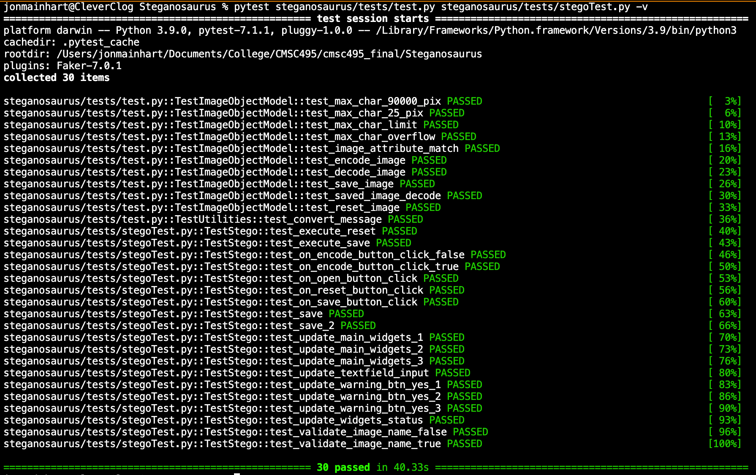

*Figure 1*. System 2 automated unit test results.

The 30 automated tests cover ImageObject methods used to encode, decode, calculate maximum message size, save, and reset images to their original state; binary encoding of messages; and front-end logic.

The manual testing of the application was successfully performed on all test systems. These tests included verifying that all buttons and fields worked as expected, that any expected user interaction worked as required, and that any unexpected user input was handled properly to prevent the application from crashing or operating outside of design parameters. Figures 2 through 18 show the output of the test cases contained in table 4.

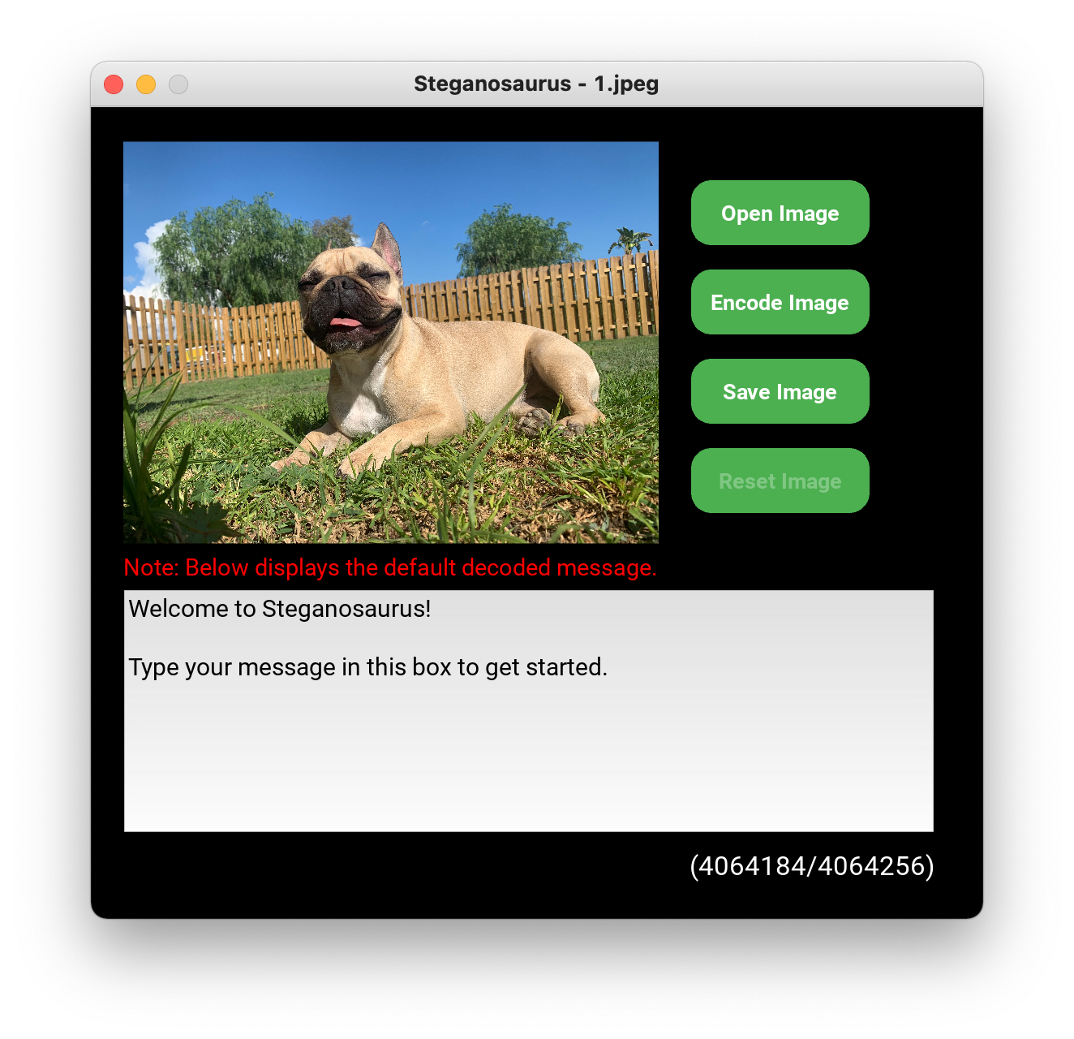

macOS

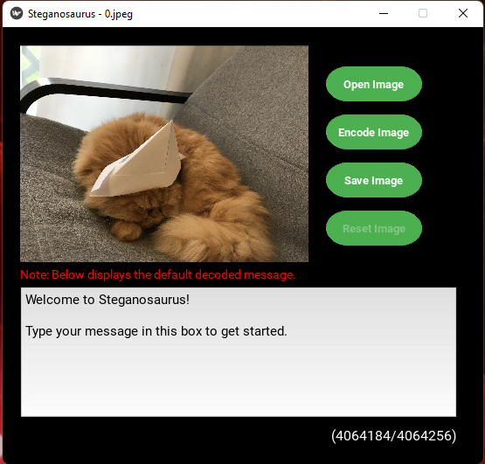

Windows

*Figure 2*. The application loads a randomized image when launched and decodes the secret message (manual test cases 4-1 and 4-2).

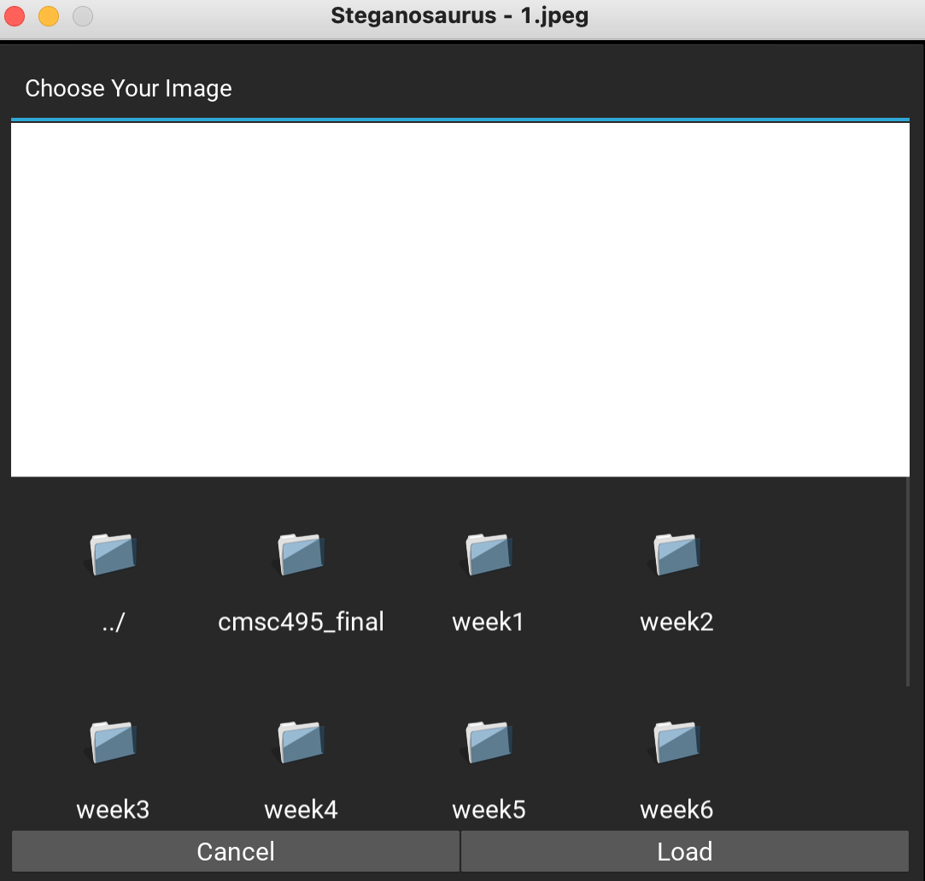

macOS

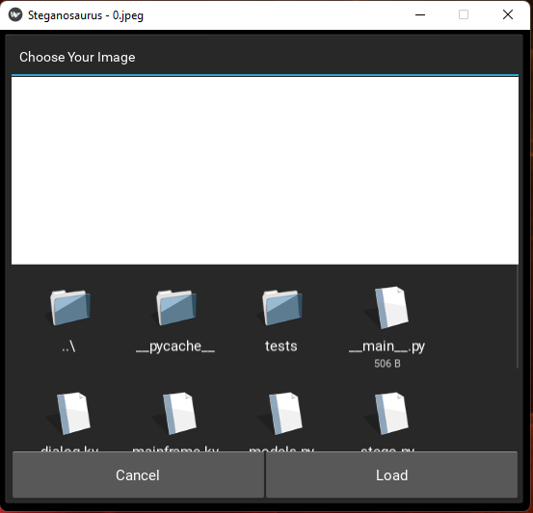

Windows

*Figure 3*. Results of clicking the “Open Image” button. The application has access to the file system (manual test cases 4-3 and 4-4).

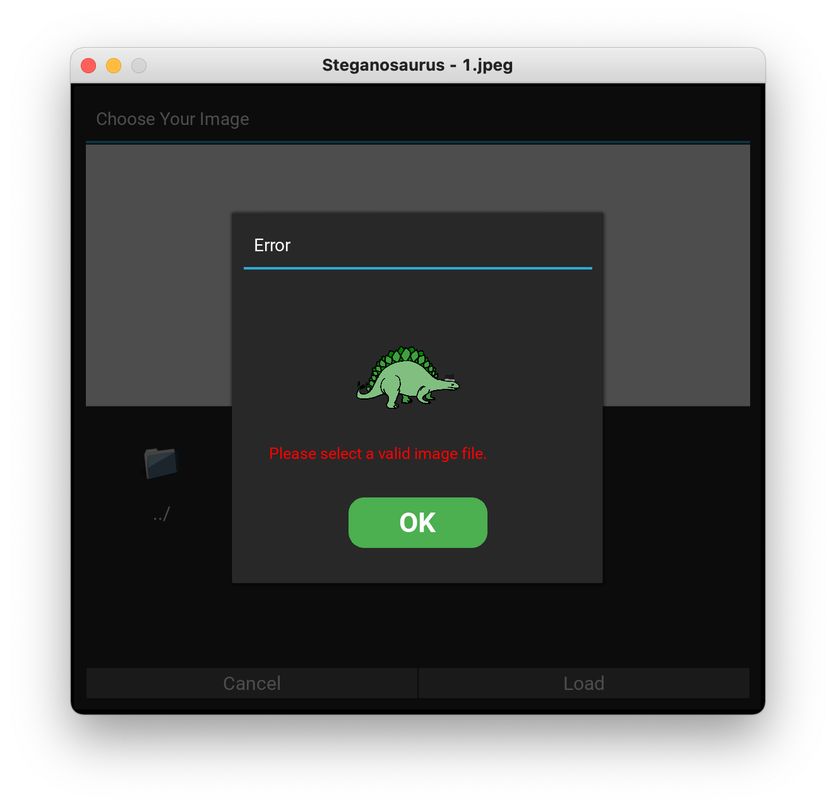

macOS

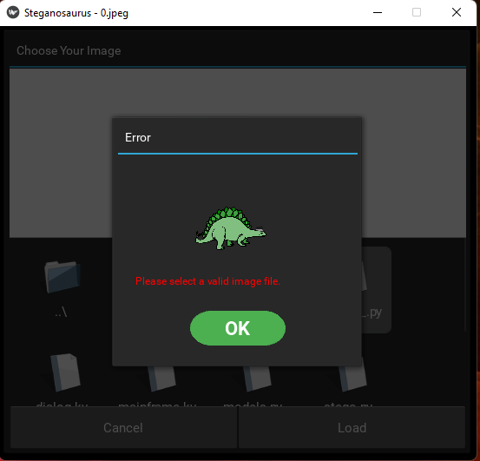

Windows

*Figure 4*. Results of attempting to open a ineligible file (Test case 4-5).

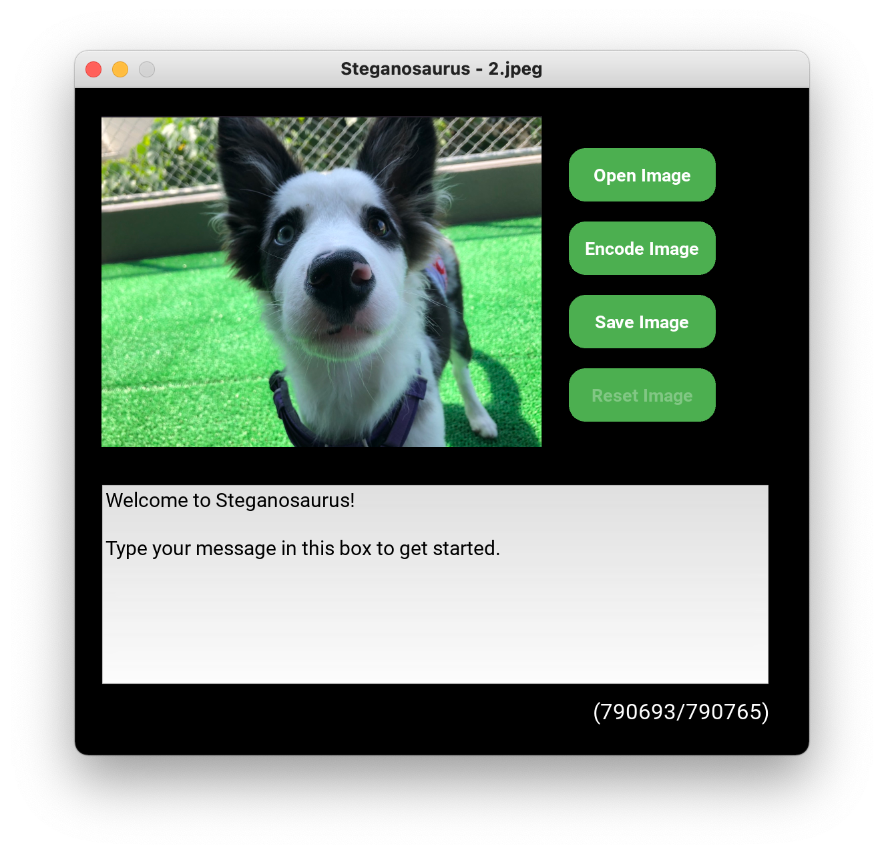

macOS

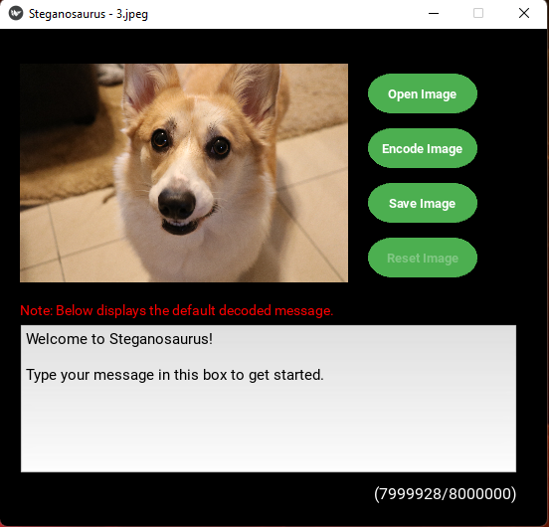

Windows

*Figure 5*. The application opens image files as expected (Test case 4-6).

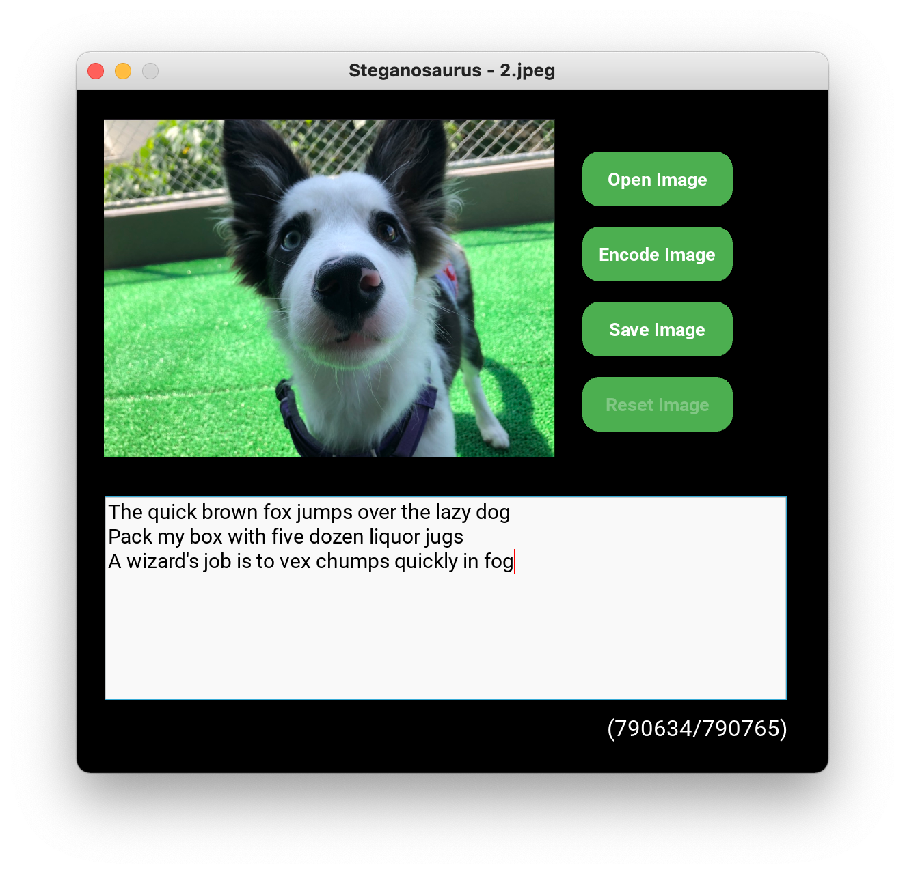

macOS

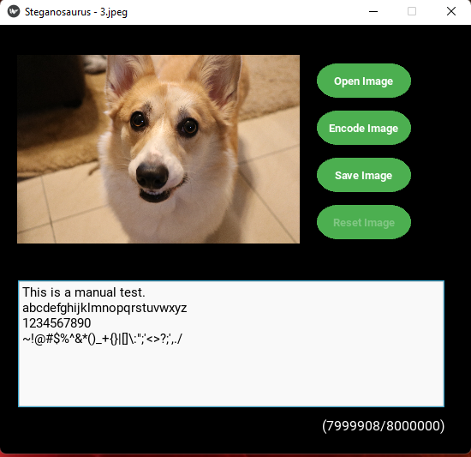

Windows

*Figure 6*. The remaining characters allowed decrease as text is input (Test case 4-8).

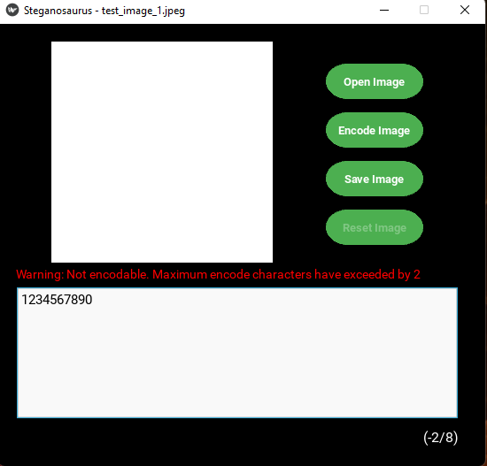

Windows

*Figure 7*. Entering too many characters displays a warning (Test case 4-9).

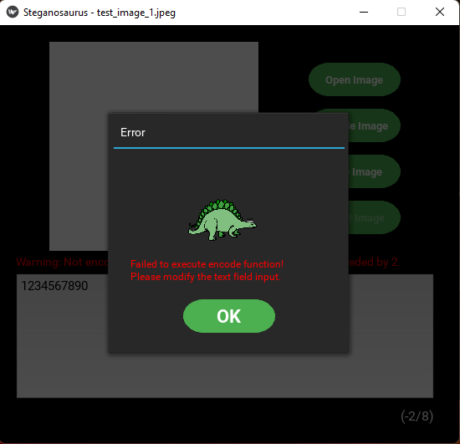

Windows

*Figure 8*. Attempting to encode an image with too many characters (Test case 4-10).

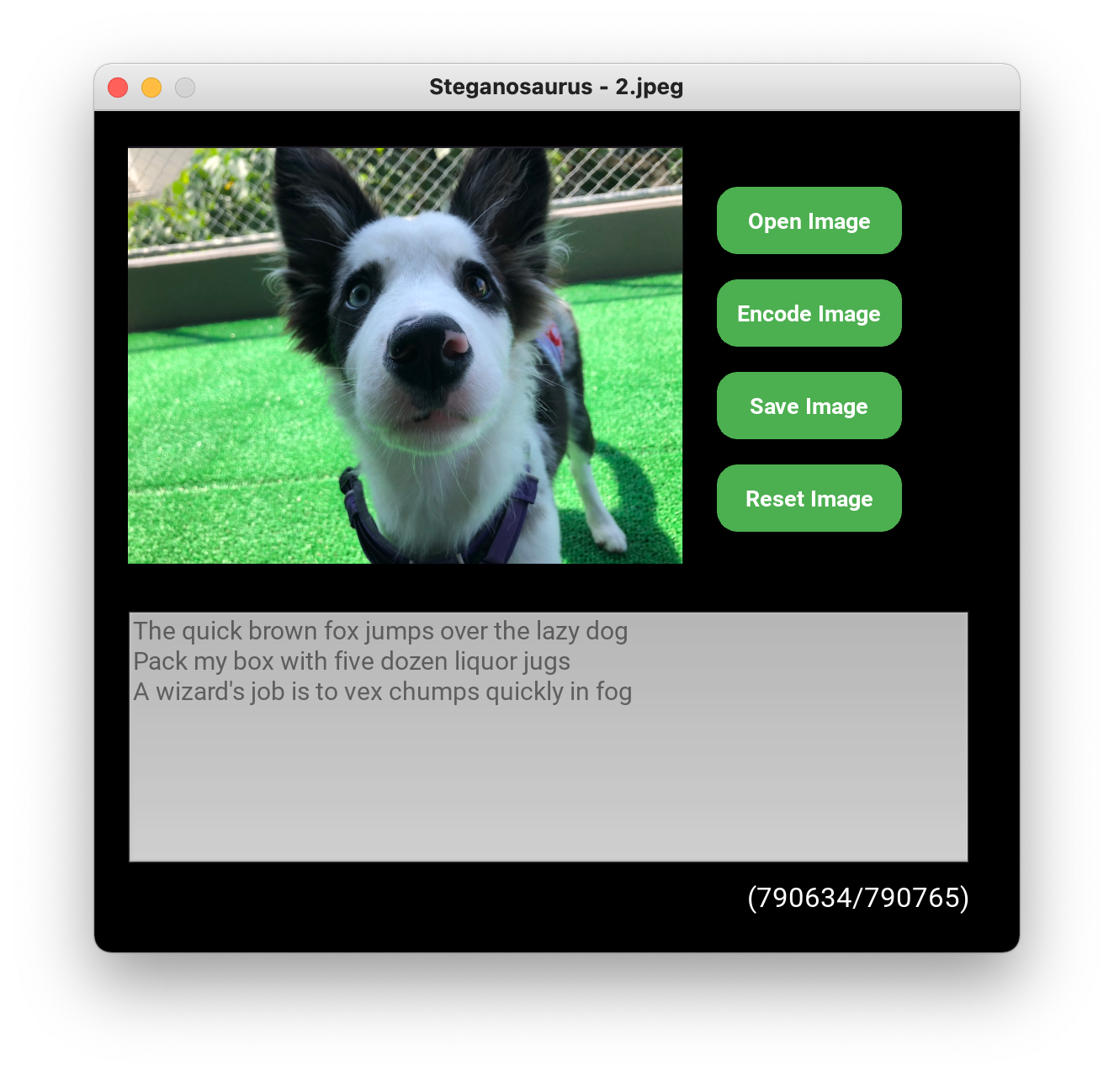

macOS

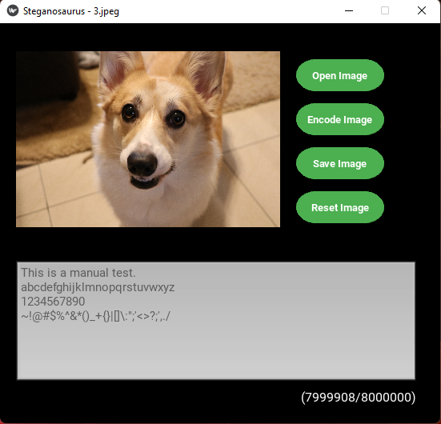

Windows

*Figure 9*. A message of the correct length will encode (Test case 4-11).

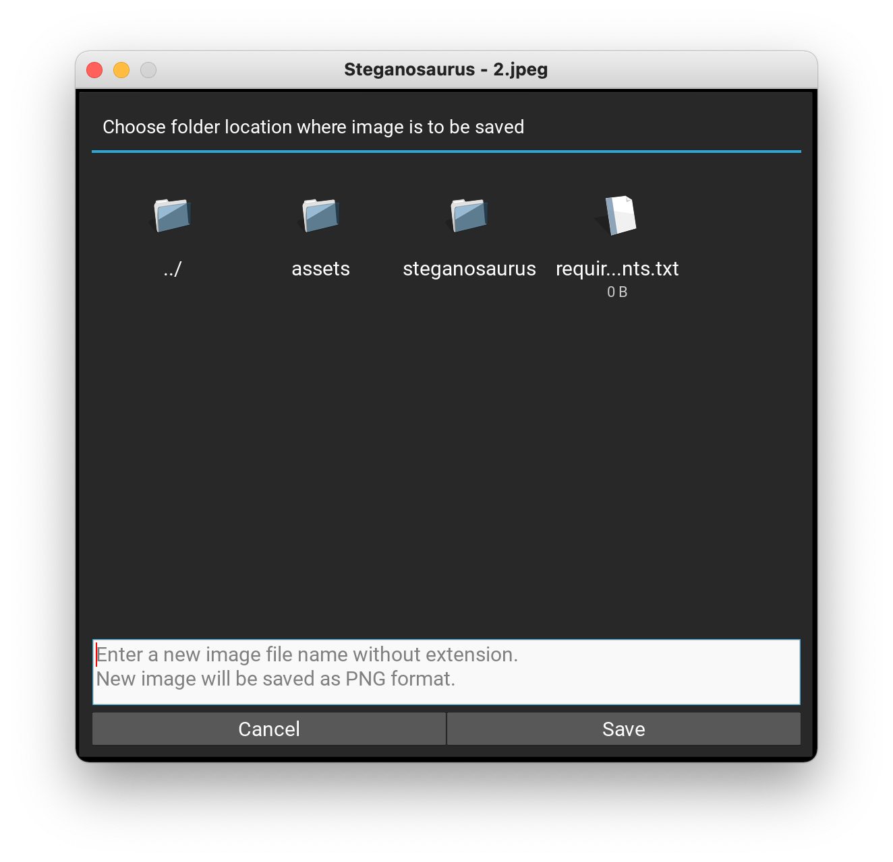

macOS

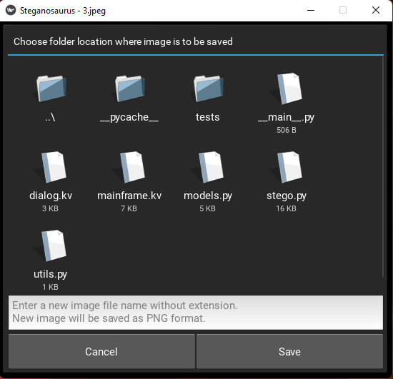

Windows

*Figure 10*. Save dialog (Test case 4-12).

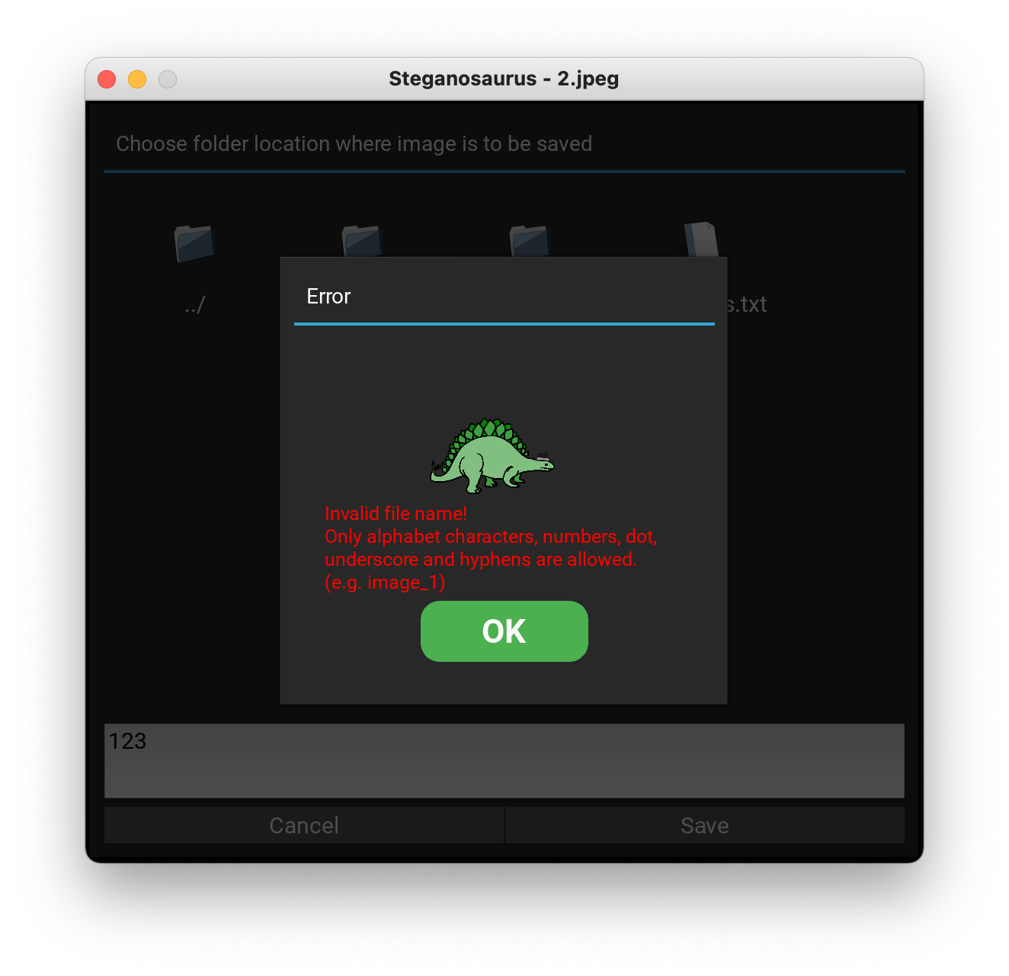

macOS

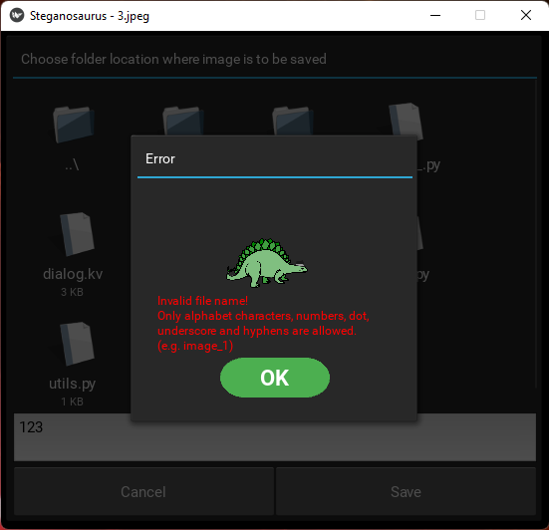

Windows

*Figure 11*. Attempting to save a file with an invalid name (Test case 4-13).

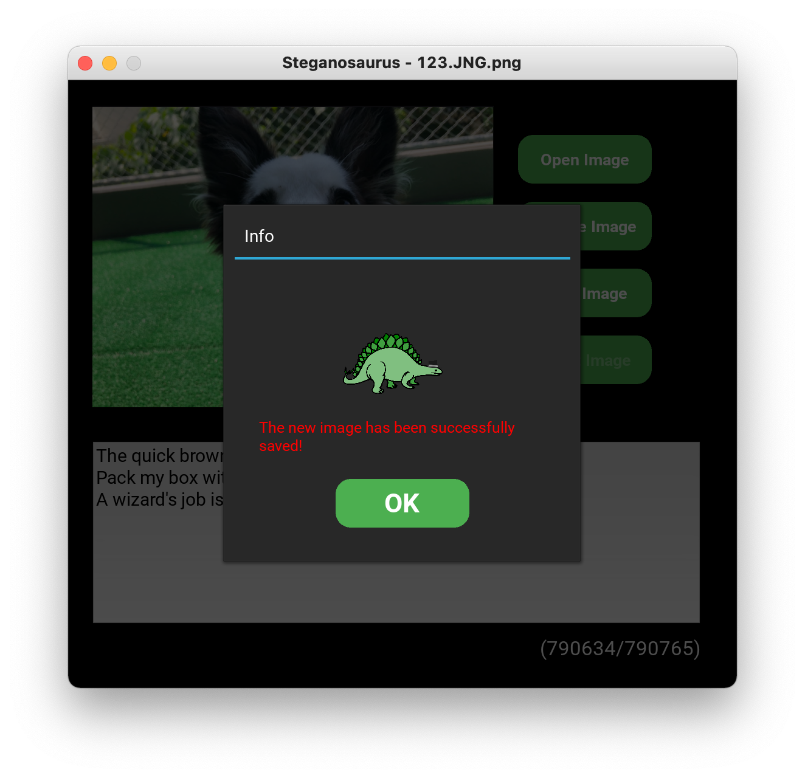

macOS

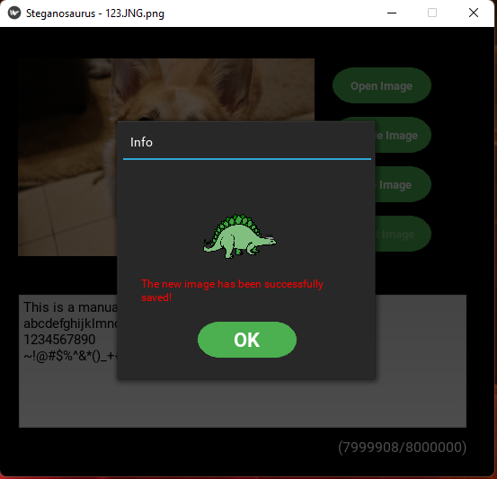

Windows

*Figure 12*. Successfully saving an image with default encoding (Test case 4-14).

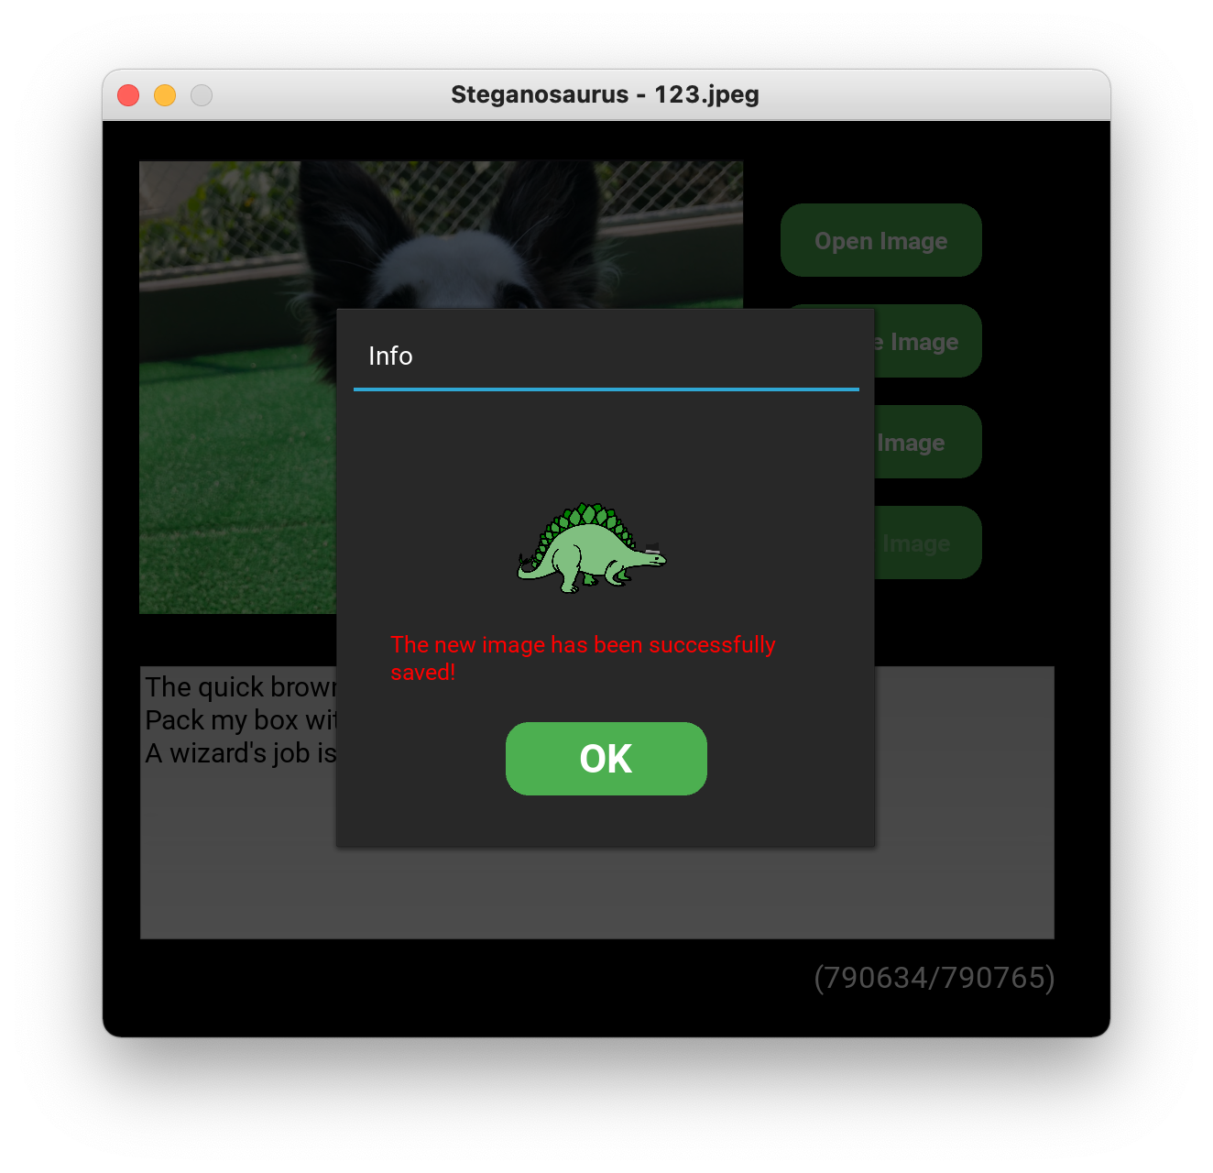

macOS

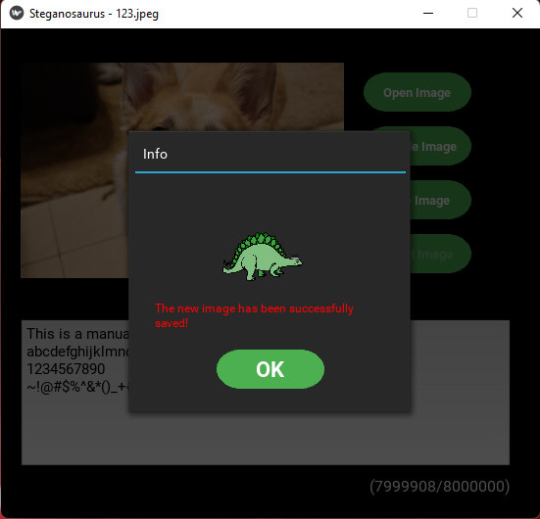

Windows

*Figure 13*. Successfully saving an image as JPEG (Test case 4-15).

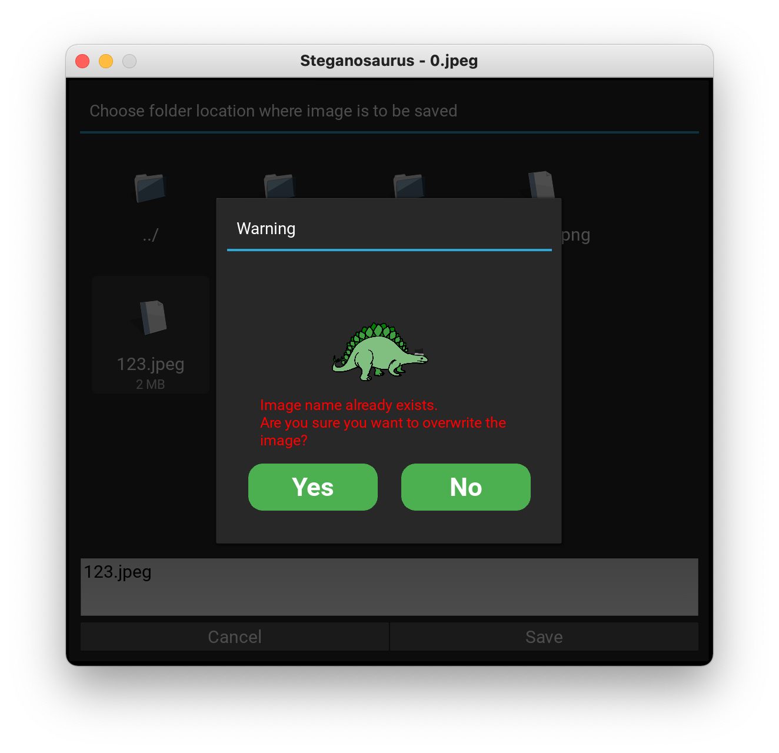

macOS

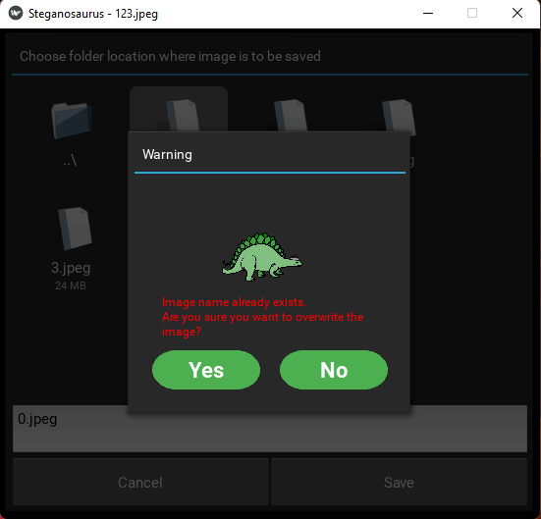

Windows

*Figure 14*. Attempting overwrite triggers warning (Test case 4-17).

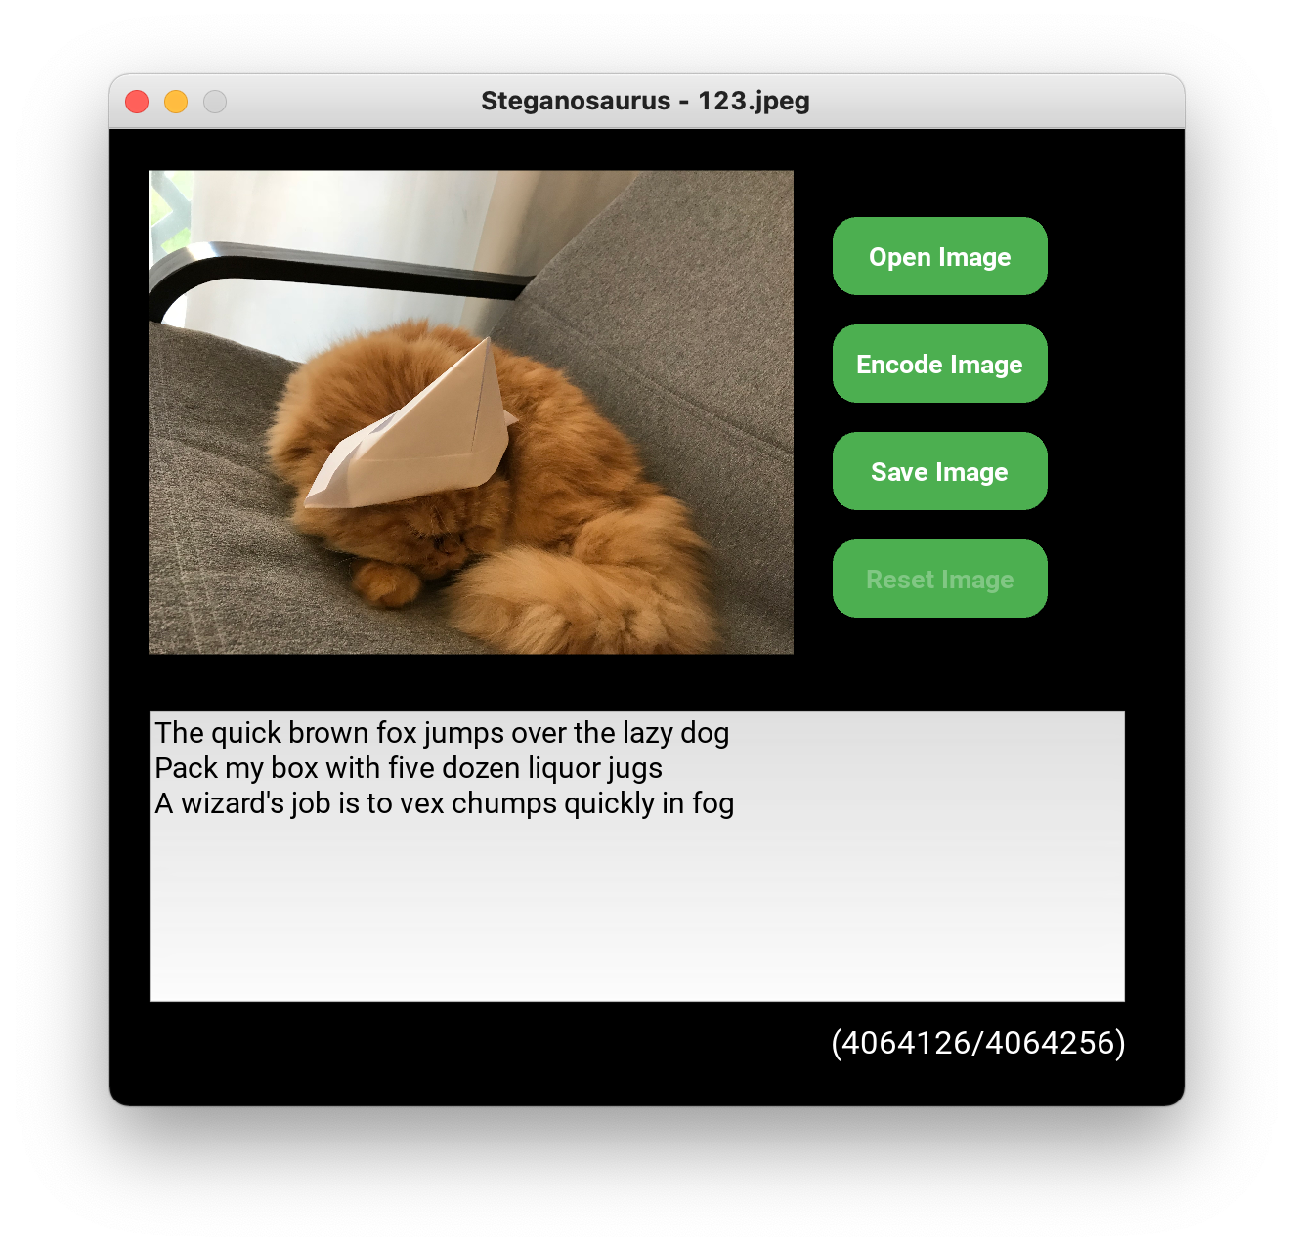

macOS

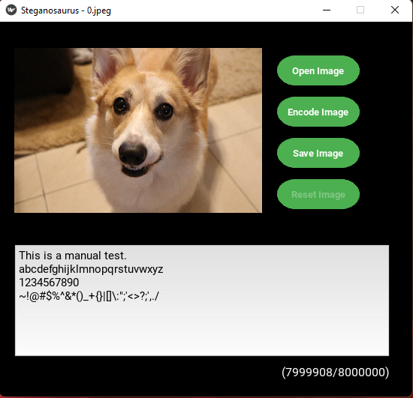

Windows

*Figure 15*. The files have been overwritten (Test case 4-17).

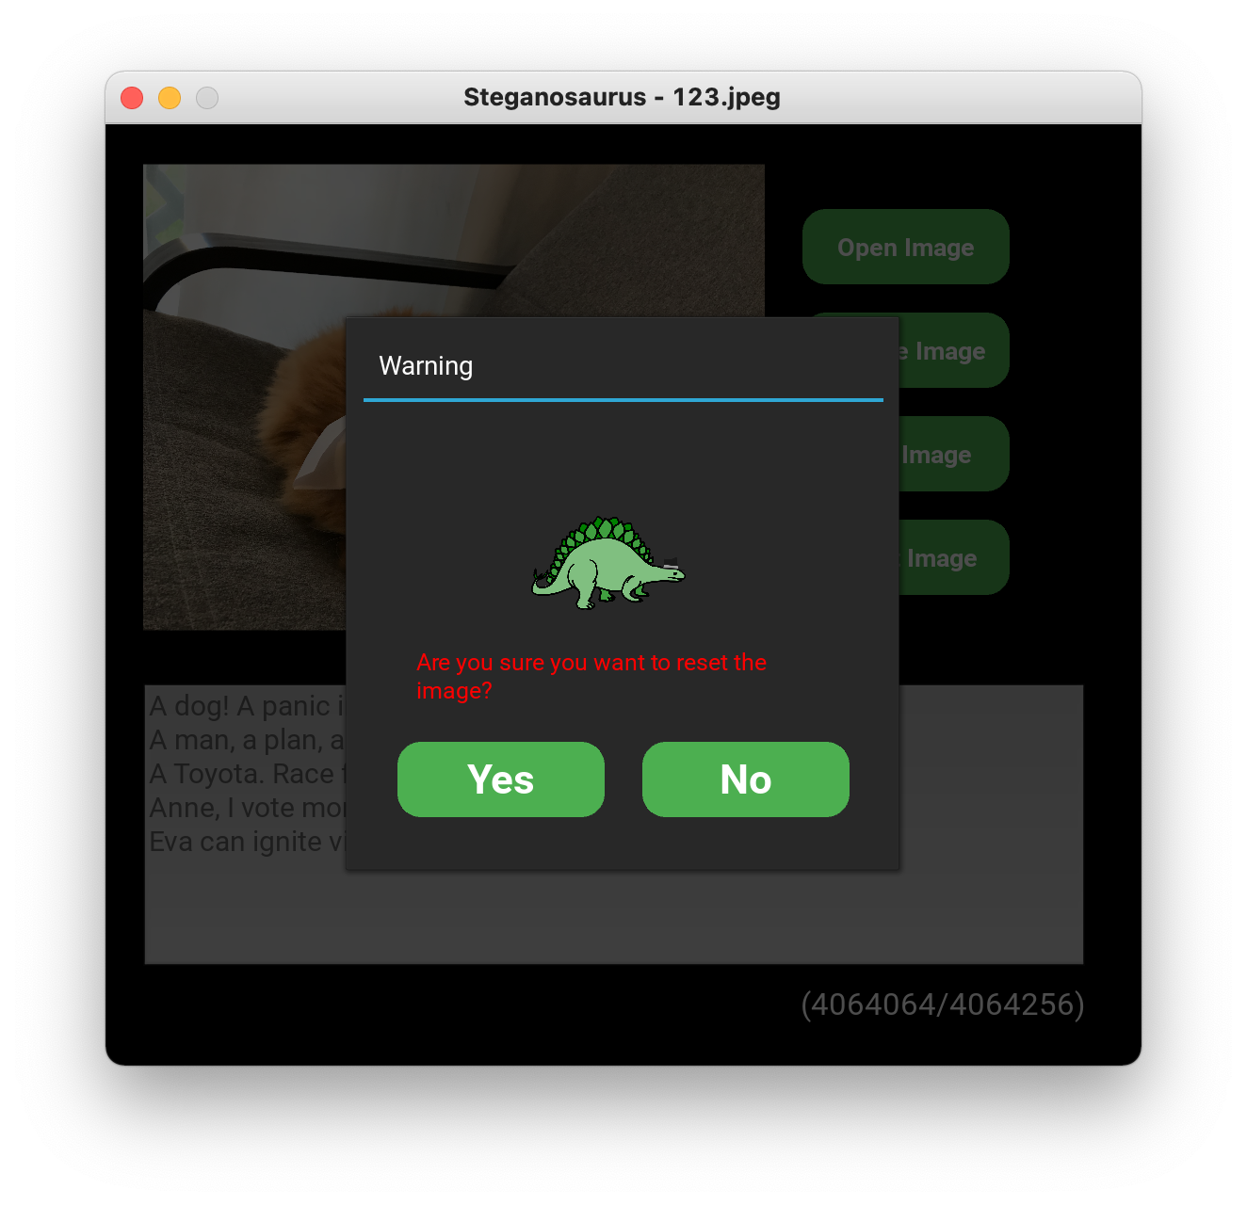

macOS

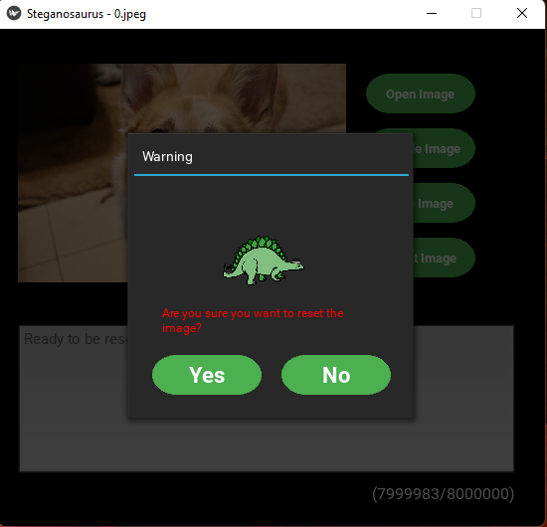

Windows

*Figure 16*. Reset button triggers warning (Test case 4-18).

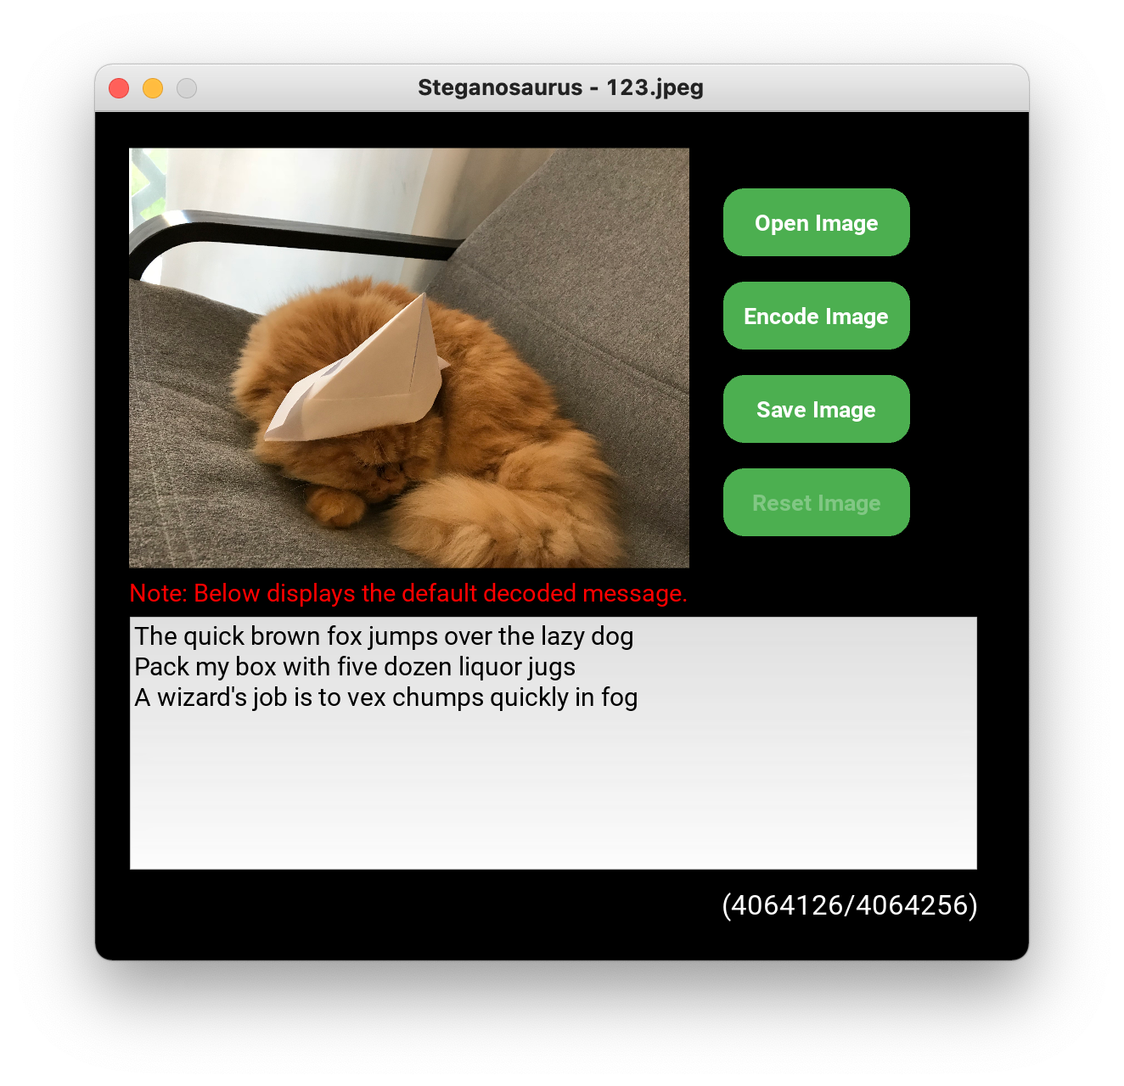

macOS

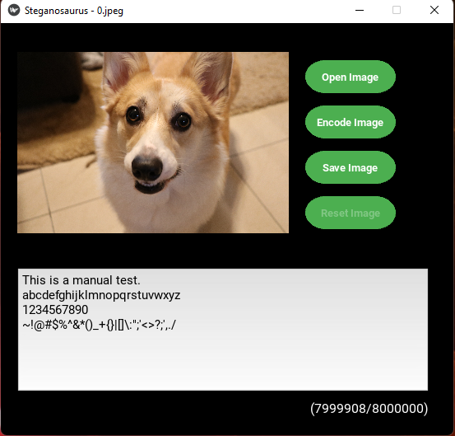

Windows

*Figure 17*. Image resets (Test case 4-18).

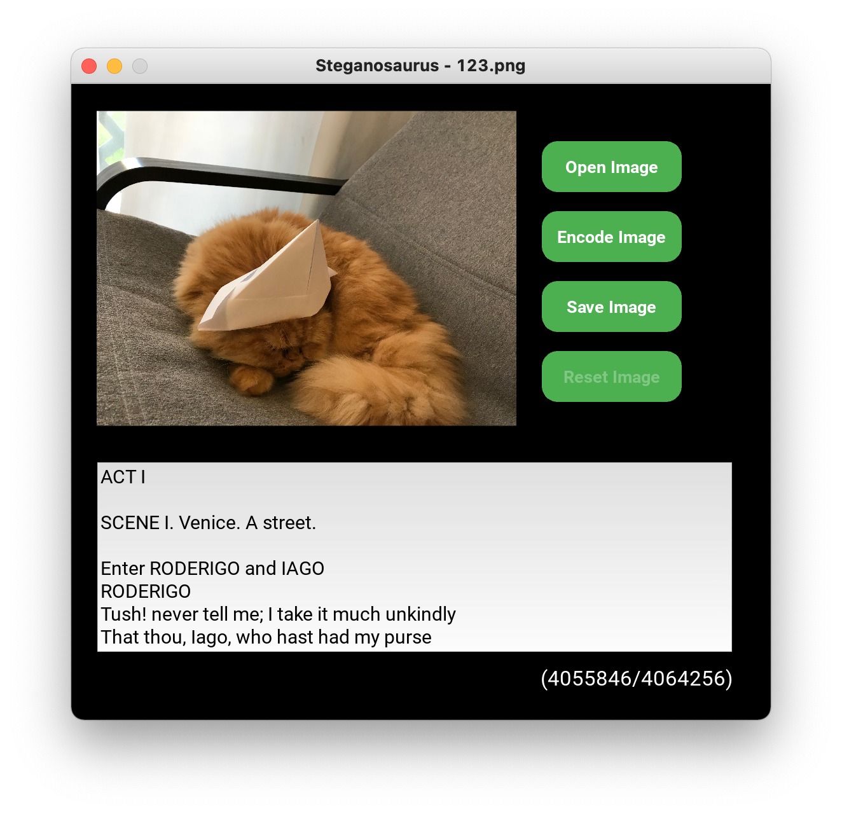

macOS

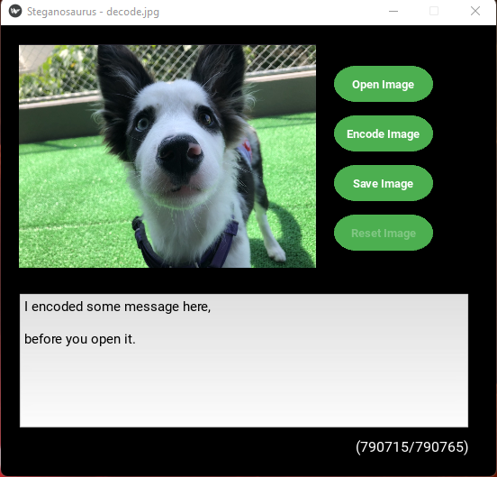

Windows

*Figure 18*. Image is decoded when opened (Test case 4-20).